Installation Pre-requisites for OpenShift Container Platform 4.6 on Bare-metal (On-premises) using User Provisioned Infrastructure.

Table of Contents

1 Introduction 3

2 Pre-requisite for OpenShift Container Platform 4.6 on vSphere 4

2.1 Compute requirements 4

2.2 Prerequisites 4

2.3 Internet and Telemetry access for OpenShift Container Platform 4

2.4 VMware vSphere infrastructure requirements 5

2.4.1 Cluster resources 6

3.1.2 Cluster limits 6

3.1.3 Networking requirements 6

3.1.4 Required IP Addresses 7

3.1.5 DNS records 7

2.5 Software prerequisites/binaries - OpenShift Container Platform 8

4. Out of Scope considerations: 9

5. References: 10

# Introduction

For deploying RedHat OpenShift 4.6 on a VMWare vSphere environment on-premises thru Installer provisioned Infrastructure.

* 1. Purpose

The purpose of this document is to provide a set of pre-requisites for Installer provisioned infrastructure of OpenShift Container Platform 4.6 on VMWare vSphere

* 1. Scope considerations:

This document gives an overview of the pre-requirements that are required to setup RedHat OpenShift v4.6 for Installer provisioned Infrastructure.

# Pre-requisite for OpenShift Container Platform 4.6 on vSphere

## Compute requirements

The following is the final hardware requirements derived from filled questionnaire shared by customer:

|  |  |  |  |  |  |
| --- | --- | --- | --- | --- | --- |
| Machine | Operating System | Sizing as per questionnaire | | Storage/node | Number of machines |
| CPU | RAM |  |  |
| Bootstrap | RHCOS | 4 | 16 | 100 GB | 1 |
| Bastion / Installation (for triggering deployment) | RHEL 7/8 | 4 | 16 | 400 GB | 1 |
| ControlPlane | RHCOS | 4 | 16 | 120 GB | 3 |
| Compute | RHCOS | 22 | 48 | 180 GB | 4 |
| HAProxy | RHEL 7/8 | 4 | 16 | 120 GB | 4 |

**Notes:**\*One of the compute nodes should have 128GB RAM, remaining Compute nodes to have 64GB RAM  
** Additional 4 TB (preferably 8TB) SSD required for each of the three storage nodes.

The compute requirements mentioned on the above table might be revisited based on customer requirements.

## Prerequisites

Provision persistent storage for the cluster. To deploy a private image registry, storage must provide ReadWriteMany access modes.

Review details about the OpenShift Container Platform installation and update processes.

If a firewall is in place, then it must be configured to allow appropriate access for the sites that the cluster requires.

## Internet and Telemetry access for OpenShift Container Platform

OpenShift Container Platform 4.6requiresInternet access to download the appropriate installers for installation of the desired cluster. The Telemetry service, which runs by default to provide metrics about cluster health and the success of updates, would require Internet access as well. When the cluster is connected to the Internet, Telemetry runs automatically, and the cluster is registered to the Red Hat OpenShift Cluster Manager (OCM).

Grant open internet access on all nodes during installation of the products to pull images for platform containers and provide telemetry data to Red Hat.

Internet access is required to:

Access the Red Hat OpenShift Cluster Manager page to download the installation program and perform subscription management. It is advised that “Telemetry” service is not disabled for accessing internet, from entitlement perspective.

Access ***Quay.io*** to obtain the packages that are required to install the cluster.

Obtain the packages that are required to perform cluster updates.

*.registry.redhat.io - Provides core container images

*.quay.io - Provides core container images

*.sso.redhat.com - The <https://cloud.redhat.com/openshift> site uses authentication from *.sso.redhat.com

*.openshift.org - Provides Red Hat Enterprise Linux CoreOS (RHCOS) images.

## VMware vSphere infrastructure requirements

Install the OpenShift Container Platform cluster on a VMware vSphere version 6 or 7 instance that meets the requirements for the components that is desired to be used.

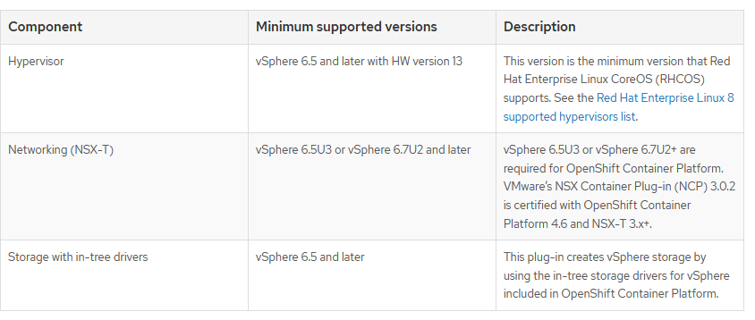

If vSphere version 6.5 instance is in use, consider upgrading to 6.7U3 or 7.0 before commencing installation of OpenShift Container Platform.

Please note:

1. Ensure that the time on the ESXi hosts is synchronized before installing OpenShift Container Platform. Refer[Edit Time Configuration for a Host](https://docs.vmware.com/en/VMware-vSphere/6.7/com.vmware.vsphere.vcenterhost.doc/GUID-8756D419-A878-4AE0-9183-C6D5A91A8FB1.html) in the VMware documentation.
2. OpenShift Container Platform generally supports compute-only vMotion. Using Storage vMotion can cause issues and is not supported.

### Cluster resources

For deploying an OpenShift Container Platform cluster that uses Installer-Provisioned Infrastructure(IPI), the installation program should be able to create several resources in the vCenter instance.

Although these resources use 856 GB of storage, the bootstrap node is destroyed during the cluster installation process. A minimum of 800 GB of storage is required to use a standard cluster.

For deploying more compute nodes, the OpenShift Container Platform cluster will need more storage.

### 3.1.2 Cluster limits

Available resources vary between clusters. The number of possible clusters within a vCenter is limited primarily by available storage space and any limitations on the number of required resources. Be sure to consider both limitations to the vCenter resources that the cluster creates and the resources that are required to deploy a cluster, such as IP addresses and networks.

### 3.1.3 Networking requirements

DHCP should be used from network perspective and ensure that the DHCP server is configured to provide persistent IP addresses to the cluster machines. Additionally, appropriate networking resources must be created before installing OpenShift Container Platform cluster:

Whitelist any site that provides resources for a language or framework that the builds require. Subsequent to OCP installation, access will be needed to ***docker.io*** and to the IBM entitled registry.

When sites such as **quay.io**is added to allowlist, do not add a wildcard entry such as ***\*.quay.io*** to the denylist. In most cases, image registries use a content delivery network (CDN) to serve images. If a firewall blocks access, then image downloads are denied when the initial download request is redirected to a host name such as cdn01.quay.io.

Grant access to the following URLs to access Red Hat Insights:

|  |  |
| --- | --- |
| cert-api.access.redhat.com | Required for Telemetry |
| api.access.redhat.com | Required for Telemetry |
| infogw.api.openshift.com | Required for Telemetry |
| <https://cloud.redhat.com/api/ingress> | Required for Telemetry and for insights-operator |

The following sites need to be whitelisted as well:

|  |  |
| --- | --- |
| mirror.openshift.com | Required to access mirrored installation content and images |
| *.cloudfront.net | Required by the Quay CDN to deliver the Quay.io images that the cluster requires |
| *.apps.<cluster_name>.<base_domain> | Required to access the default cluster routes unless ingress wildcard is set during installation |
| quay-registry.s3.amazonaws.com | Required to access Quay image content in AWS |
| api.openshift.com | Required to check if updates are available for the cluster |
| art-rhcos-ci.s3.amazonaws.com | Required to download Red Hat Enterprise Linux CoreOS (RHCOS) images |
| api.openshift.com | Required for the cluster token |
| cloud.redhat.com/openshift | Required for the cluster token |
| registry.access.redhat.com | Required for odo CLI. |

* oauth-openshift.apps.<cluster_name>.<base_domain>
* console-openshift-console.apps.<cluster_name>.<base_domain>

### 3.1.4 Required IP Addresses

An Installer-Provisioned vSphere installation requires two static IP addresses for the installation OpenShift Container Platform cluster:

* The **API** address is used to access the cluster API.
* The **Ingress** address is used for cluster ingress traffic.

### 3.1.5 DNS records

DNS records must be created for two static IP addresses in the appropriate DNS server for the vCenter instance that hosts the OpenShift Container Platform cluster. In each record, <cluster_name> is the cluster name and <base_domain> is the cluster base domain that is specified when the cluster is installed. A complete DNS record takes the form: <component>.<cluster_name>.<base_domain>.

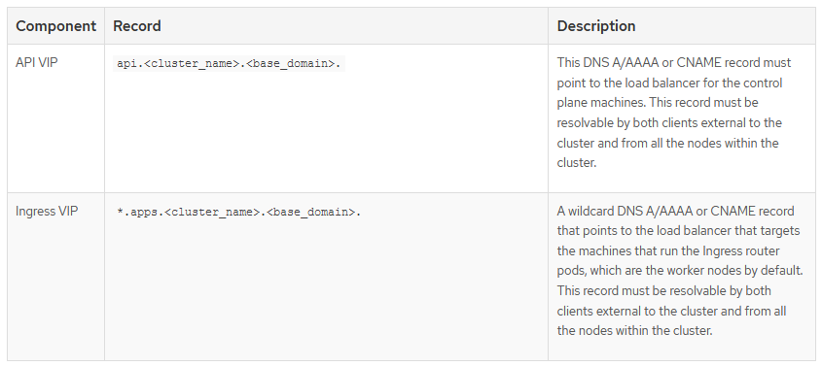

## Software prerequisites/binaries - OpenShift Container Platform

* Download the installation binaries for OpenShift Container Platform 4.6 for the installation type from <https://mirror.openshift.com/pub/openshift-v4/x86_64/clients/ocp/stable-4.6/> on a local computer. Installation of the cluster can be done from a computer that uses RHEL 7/8.
* Files to download
* <https://mirror.openshift.com/pub/openshift-v4/x86_64/clients/ocp/stable-4.6/openshift-install-linux-4.6.20.tar.gz>
* <https://mirror.openshift.com/pub/openshift-v4/x86_64/clients/ocp/stable-4.6/openshift-client-linux-4.6.20.tar.gz>
* From <https://cloud.redhat.com/openshift/install/pull-secret>, obtain the pull secret as a txt file. This pull secret allows to authenticate with the services that are provided by the included authorities, including Quay.io, which serves the container images for OpenShift Container Platform components.
* Obtain the RHCOS OVA images that are required for installing operating system instances from
* <https://mirror.openshift.com/pub/openshift-v4/dependencies/rhcos/4.6/latest/>

The file name contains the OpenShift Container Platform version number in the format rhcos-<version>-vmware.<architecture>.ova

## Out of Scope considerations:

* The details mentioned here were obtained from official RedHat public website given on the reference. Therefore, any changes on the existing pre-req changes on RedHat would be applicable here too.
* We must go with RedHat recommended pre-requirements and deviating from the mentioned pre req may lead to unexpected results.

# References:

<https://docs.openshift.com/container-platform/4.6/installing/installing_vsphere/installing-vsphere-installer-provisioned.html>